Local SEO Site Structure Blueprint (2025)

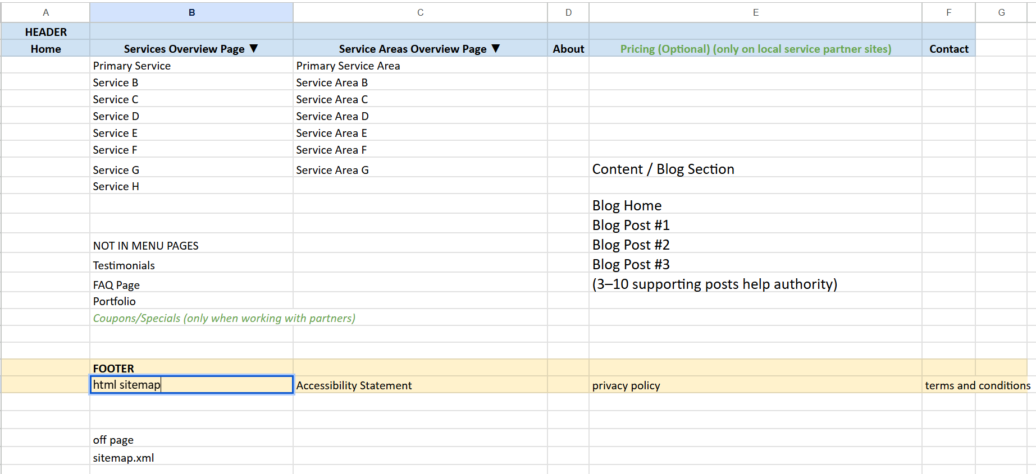

Overview
Local SEO success begins with a well‑planned website structure. A logical hierarchy and internal linking system tell search engines what you offer, where you operate and why your pages deserve to rank. Without structure, even excellent content struggles to surface. This blueprint synthesises 2025 best practices from leading local‑SEO experts, Google documentation and hands‑on case studies. It is designed for scalability (rank‑and‑rent or multi‑location businesses) and to guide virtual assistants or developers building dozens of local service sites.
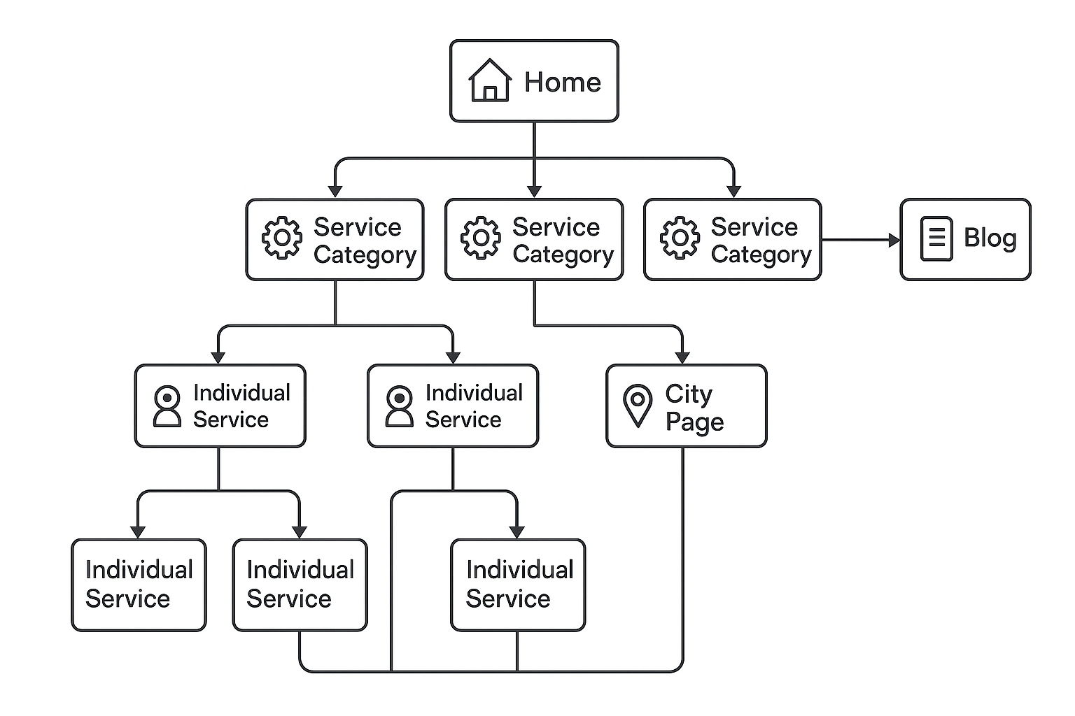
The diagram above uses a hub‑and‑spoke model: a central home page funnels authority to category hubs, which in turn link to individual service pages and city pages. A blog/off‑site content section supports topical authority and links back to service pages.

1. Core Principles of Site Architecture
- Shallow hierarchy: Important pages should be reachable within three clicks of the home page. Flat structures help crawl efficiency and distribute link authority evenly, whereas deep structures bury key pagesagent6.com.au.
- Hub–and‑spoke pyramid: Build a pyramid with your Home page at the top, category hub pages in the middle, and clusters of child pages (service and location pages) underneathagent6.com.au. Hubs summarise a topic and link to focused child pages; child pages link back to the hub and laterally to siblings when relevantagent6.com.au.
- Readable URLs: Use words and hyphens rather than cryptic IDs; keep paths short and meaningfulagent6.com.au. Choose slug patterns that match audience language—e.g., emergency‑plumbing‑chicago or /chicago/emergency‑plumbing. Experts on Local Search Forum favour the simpler “service‑city” slug (Type A), noting it’s easier to scalelocalsearchforum.com.
- Breadcrumbs & navigation: Implement breadcrumb trails near the top of pages to show location within the hierarchy; add structured data so Google can display breadcrumbs in search resultsagent6.com.au. Use navigation menus to introduce services but rely on content‑embedded links to convey hierarchyoptuno.com.
- XML & HTML sitemaps: Generate an XML sitemap and submit it via Google Search Console; ensure HTML sitemaps are human friendly and organised by category.
- Silo structure and supporting pages: Local SEO expert Matt Diggity advocates building a hierarchical “silo” architecture where broad parent pages serve as general introductions and supporting pages cover narrower subtopics. These pages are connected through internal links to pass topical relevance and link equitydiggitymarketing.com. Diggity distinguishes between soft silos (pages are linked together through navigation and contextual links) and hard silos (URL directories reflect the structure)diggitymarketing.com. Begin with keyword research, identify core topics and break them into supporting pages for long‑tail keywordsdiggitymarketing.com.
- Separate service pages & pyramid linking: Local SEO tactician Greg Gifford stresses that each service deserves its own page rather than combining multiple services on one pagedannyleibrandt.com. Ensure consistency across title tags, H1 headings, URL slugs, alt text and meta descriptions for each service pagedannyleibrandt.com. Gifford describes site architecture as a pyramid: the homepage is the hub; middle‑layer category pages link to detailed service pages; and service pages link only to content that furthers the customer journeydannyleibrandt.com.
- Strategic internal linking experiments: Data from SearchPilot’s SEO A/B tests show that internal linking can have measurable impacts. Adding links to nearby geographic regions on a site with thousands of regional pages increased organic traffic by 7 % on the destination pagessearchpilot.com. Reducing the number of links in a link block improved the ranking of the remaining linked pagessearchpilot.com. Updating internal links to avoid 301 redirect chains improved crawl efficiency and user experiencesearchpilot.com. These tests underscore the value of deliberate internal linking patterns rather than random link placement.
- Clean up content structure and internal linking: Link‑building expert Bibi Raven notes that many companies are now targeting top‑of‑funnel keywords and, importantly, cleaning up their content structure and internal linkingmajestic.com. A tidy site with clear topic clusters makes it easier to build relevant backlinks and helps search engines and users navigate your content.

2. Homepage – Your Local Authority Hub
The home page is the core of your local SEO footprint. According to ThatWare’s blueprint, it should act as the landing page for your Google Business Profile (GBP) and local authority hubthatware.co. Key elements include:
- Title & H1 structure: Use your primary service and city in the title tag and H1 (e.g., “Plumbing Services in Chicago | 24/7 Experts”)thatware.co. Reiterate your primary keyword + city in the opening paragraph to align with user intentthatware.co.
- Mini‑site map: Briefly describe your main services, service areas and unique selling proposition. This helps visitors (and Google) understand the scope of your businessthatware.co.
- LocalBusiness schema: Implement LocalBusiness schema using JSON‑LD. Include required fields (name, address, phone), and add recommended properties like aggregateRating and geo coordinatesdevelopers.google.com. Use a specific subtype (e.g., Plumber, DaySpa) and ensure your business name and NAP (Name, Address, Phone) exactly match your GBP and citationsthatware.co.
- GBP category alignment: List all relevant GBP categories (Google allows up to 10) and reflect them as sections or H2s on the homepage, with 300–400 words describing eachthatware.co. This establishes topical relevance and helps the GBP and site reinforce each other.
- Internal links: Link to primary category pages from the home page, forming the first tier of the hub‑and‑spoke networkthatware.co.

3. Category Hubs & Secondary Services
For each main service category (often corresponding to GBP categories or key profit centres), create a category hub page. For multi‑location businesses this page is typically under a city path (e.g., /chicago/emergency‑plumbing). Best practices include:
- URL & headings: Use /city/service-category or service‑category‑city slugs. The H1 should combine service and city (e.g., “Emergency Plumbing Services in Chicago”)thatware.co.
- Content structure: Explain sub‑topics (e.g., for plumbing: tankless vs. traditional heaters) and mention neighbourhoods or ZIP codes servedthatware.co.
- FAQ schema: Add a FAQs section marked up with FAQPage structured data. This increases your chance of appearing in People Also Ask snippetsthatware.co.
- Internal linking: Link down to related service pages and back up to the home page. Provide contextual anchor text (“learn about our water‑heater installation process”) to connect pages naturallyoptuno.com.

4. Service‑Specific Pages
Service pages are your conversion engines. ThatWare emphasises creating 30–50 service pages—one per distinct servicethatware.co. Sterling Sky’s research supports this: each major service deserves its own “service in location” pagesterlingsky.ca. Guidelines:
- Individual focus: Each page targets a single service + city. Avoid combining similar services on separate pages to prevent keyword cannibalisationsterlingsky.ca.
- Length & structure: Aim for 800–1,500 words. Include an introduction, benefits, process or methodology, pricing ranges, areas served and a strong call‑to‑actionthatware.co.
- Unique content: Avoid duplicate copy. Highlight expertise, employee experience, testimonials and unique visuals—photos, videos, infographicssterlingsky.ca. Use first‑party statistics, case studies, unique selling points, customer reviews and common questionssterlingsky.ca. Show staff bios and quotes to demonstrate real‑world expertisesterlingsky.ca.
- Local flavour: Add local information such as landmarks, events and neighbourhood anecdotes; mention your company’s connection to the area (e.g., Chamber of Commerce membership)sterlingsky.ca.
- Service area linking: Include a “service areas” section linking to location pages; use branded or semi‑branded anchor text so that each service page supports your hyperlocal pagesthatware.co.
- Schema markup: For services that include common questions or pricing, use FAQPage or Product schema as appropriate; add Offer sub‑objects inside LocalBusiness schema to describe specific servicesthatware.co.
- Continuous improvement: Monitor rankings and user behaviour. Update content and add new pages where necessary; Sterling Sky advises against set‑and‑forget contentsterlingsky.ca.

5. Location/City Pages (Service Area Pages)
City or neighbourhood pages help capture searches like “plumber in {city}”. Sterling Sky’s study provides guidance:
- Create only when needed: Not every city requires a page. Use them when competition or the size of the service area warrants itsterlingsky.ca. For multi‑city operations, create a page for each location + service combination if the main location page isn’t rankinglocalsearchforum.com.
- Unique content: Avoid duplicating your service pages. Make city pages unique by discussing local landmarks, events, demographics and your company’s community involvementsterlingsky.ca. Mention employees who live in the area; link to their bios or relevant external profilessterlingsky.ca.
- Link to services: City pages should summarise all services offered in that area, using bullet points and linking to detailed service pagessterlingsky.ca. This guides both users and Google to the correct pages.
- SEO details: Use the city and service in the title tag and H1. Include your NAP and embed a Google Map. Add LocalBusiness structured data with the areaServed property specifying the neighbourhoodthatware.co.

6. Programmatic Hyperlocal Pages
Covering every suburb or ZIP code manually is impractical. Programmatic SEO allows you to create template‑based pages at scale. ThatWare suggests using a URL pattern like /service-area/neighborhood/service and populating content with variables (neighbourhood names, service types, testimonials)thatware.co. Customise at least the first 200 words, FAQs and CTAs to avoid thin‑content penaltiesthatware.co.

7. Internal Linking Strategy
Internal links connect your site into a cohesive network. Optuno’s 2025 article advocates a “linkframe”—a highway system rather than random streetsoptuno.com. Key practices:
- Build gravity with local service pages: Treat each city or service page as a local storefront. Link to these pages from blog posts, navigation, home page and contact pages so they receive continuous internal link equityoptuno.com.
- Create topical hubs: Publish a cluster of 5–7 articles around a subtopic and interlink them. Each article links back to the corresponding service page and to each otheroptuno.com. This demonstrates topical authority and improves ranking for long‑tail queries.
- Prioritise deep pages: Most sites overlink to the home and contact pages. Instead, link to deep service pages and resourcesoptuno.com. Users will stay longer and send positive engagement signals to Google.
- Descriptive anchor text: Use anchors that hint at the linked page’s content (“Learn how our Orlando roofing inspections prevent storm damage”) instead of generic “click here”optuno.com. Vary anchor text with exact phrases, partial matches and synonymsagent6.com.au.
- Keep it human: Links should be placed where they add value and not interrupt the reader’s flowoptuno.com. Avoid stuffing your copy with links; 2–5 relevant internal links per page is a good ruleagent6.com.au.
- Geo‑fence authority: Create content around a specific region and link it back to the target service page (e.g., articles about desert landscaping linking to “Landscaping in Scottsdale”)optuno.com. This helps dominate particular geographic terms.
- Audit & refresh: Regularly review older posts and add links pointing to high‑value pagesoptuno.com. Fix orphan pages and remove outdated link farms; footer link farms with dozens of city names are now a red flagoptuno.com.
- Navigation & breadcrumbs: Combine menu links with contextual links; do not rely solely on the nav menu. Use breadcrumb markup for contextagent6.com.au.

8. Schema Markup & Structured Data
Structured data helps search engines understand your business and can trigger rich results. Follow Google’s LocalBusiness guidelines:
- Define each location as a LocalBusiness subtype (e.g., Plumber, Restaurant) and include required properties (name, address with street, city, region, postal code, country)developers.google.com. Include recommended properties such as aggregateRating, department, geo coordinates, openingHoursSpecification, priceRange, telephone and urldevelopers.google.com.
- Multiple services: When a single business offers multiple services, you can specify an array of types (e.g., "@type": ["Electrician", "Plumber", "Locksmith"])developers.google.com.
- Extend schema for services: Use Offer within LocalBusiness to describe a specific service (e.g., “Emergency Plumbing Services”)thatware.co. Add areaServed and aggregateRating properties to highlight where you operate and your ratingthatware.co.
- FAQ & Breadcrumb markup: Mark up FAQ sections using FAQPage and add BreadcrumbList markup to breadcrumbsagent6.com.au.
- Validate & test: Use Google’s Rich Results Test to validate your structured data and fix any errorsdevelopers.google.com.

9. Additional Strategies & Maintenance
- Local content and media: Feature videos, before‑and‑after photos, team photos and customer reviews on service pages to build truststerlingsky.ca. Video content hosted on your own domain can surface in video search resultssterlingsky.ca.
- GBP engagement: Keep your Google Business Profile active with regular posts, fresh photos and quick replies to reviews. Ensure your GBP categories align with your website’s categoriesthatware.co.
- Citation consistency: Ensure NAP information is consistent across your website, GBP and citations. Inconsistencies confuse search engines and weaken local authoritythatware.co.
- Sitemaps & robots.txt: Maintain updated XML sitemaps; ensure important pages aren’t accidentally blocked by robots.txt or noindex tags. Submit new URLs via Search Consoledevelopers.google.com.
- Link building & citations: After the site structure is in place, pursue local backlinks from relevant directories, local organisations and industry blogs. Build citations on high‑quality platforms; ensure each citation matches your NAP.
- Programmatic expansions: For multi‑location rank‑and‑rent portfolios, use programmatic templates with 20 % customised content for each neighbourhood pagethatware.co. Prioritise areas with search demand and update pages as necessary.

10. Implementation Checklist & Timeline
Step | Description | Responsible | Notes
1. Competitor & Keyword Research | Identify core services, target cities, search volumes and GBP categories. Spy on competitors’ GBP categories and top ranking pagesthatware.co. | SEO Strategist | Use tools like GMBSpy, Ahrefs.
2. Build Site Skeleton | Map out home page, category hubs, service pages, city pages and legal pages. Ensure each important page will be within 3 clicks of homeagent6.com.au. | Project Manager | Create a flowchart using the hub‑and‑spoke model.
3. Develop Home Page | Write copy using primary service + city; list services, service areas and USP; implement LocalBusiness schema; link to category hubsthatware.co. | Copywriter/Developer | Add GBP categories as sections.
4. Create Category Hubs | For each main service, build a page with sub‑topics, FAQs and internal links down to service pagesthatware.co. | Content Team | Use FAQPage schema for FAQs.
5. Produce Service Pages | Create high‑quality pages for each service + city with unique content, first‑party statistics and visualssterlingsky.ca. | Content & Design | Add Offer structured data; CTA section.
6. Build City/Location Pages | For cities/neighbourhoods with search demand, create unique pages that summarise all services, include local info and link to service pagessterlingsky.ca. | Content Team | Embed maps; include local stories.
7. Programmatic Hyperlocal Pages (optional) | Use templates to generate pages for long‑tail neighbourhoods or suburbs; customise introduction, FAQs and CTAsthatware.co. | Developer | Use variables for neighbourhood and service.
8. Implement Internal Linking | Create navigation menus and breadcrumbs; embed contextual links using descriptive anchor text; build topical clusters and link them to service pagesoptuno.comoptuno.com. | Content & SEO | Audit quarterly to add links and remove link farms.
9. Add Schema Markup | Add LocalBusiness, BreadcrumbList, FAQPage and Offer schema where appropriate; validate via Rich Results Testdevelopers.google.com. | Developer | Document all structured data.
10. Quality Assurance | Test that pages load quickly, are mobile friendly and accessible. Check NAP consistency. Ensure no duplicate content. Validate internal linking and schema. | QA Specialist | Use Search Console for crawl errors.
11. Launch & Monitor | Submit sitemaps; track rankings, CTR and conversions. Adjust pages and links based on performance; update content regularlysterlingsky.ca. | SEO Team | Use geo‑grid tools like Local Falcon to monitor rankings across locationsthatware.co.

Conclusion
A scalable local SEO system demands more than technical tricks—it requires a structured website that aligns user intent with search engine signals. By organising your pages into a logical hierarchy, creating focused service and city pages, and connecting them through thoughtful internal links, you create a network that both users and search engines can navigate easily. Adding structured data, unique local content and continuous maintenance further strengthens your authority. Use this blueprint as a living document: adapt it to your niche, expand it across cities and iterate based on data. The reward is not just better rankings but a resilient asset that generates leads and can be replicated across multiple markets.
Let me know if you need any more adjustments or want help tailoring it to a particular niche.
Sources

You said:
So. 15-30 page sites. What's the layout skeleton

ChatGPT said:
Got you. Here is the proven, scalable 15–30-page local SEO site skeleton used by the best operators (Diggity, Gifford, Willie, Sterling Sky principles). This is the exact structure you can hand to a VA and replicate across 50+ rank-and-rent sites.

⭐ THE 15–30 PAGE LOCAL SEO SITE SKELETON
Designed for fast launches, strong topical coverage, and clean silo structure.

✅ SECTION 1 — CORE FOUNDATION (3–5 pages)

1. Home Page
- Strong value prop
- Service list
- Service-area list
- FAQ preview
- CTA buttons
- Trust signals (badges/reviews)

2. About Page
- Local credibility
- Experience + qualifications
- Service area summary
- Internal links to Home, Services, Cities

3. Contact Page
- Click-to-call
- Embedded map
- Simple contact form
- Service areas

4. Service Area Overview Page (optional but recommended)
- List all cities served
- Short summaries
- Internal links to city pages
- Helps Google understand geography

✅ SECTION 2 — MAIN MONEY PAGES (5–12 pages)
These are your #1 ranking assets.

5. Primary Service Page (1 page)
Example: “Tree Removal Service”
This is the “hub” for the whole service silo.

6–12. Individual Service Pages (4–10 pages)
Examples:
- Tree Trimming
- Emergency Tree Removal
- Stump Grinding
- Lot Clearing
- Storm Cleanup
- Brush Removal
- Commercial Tree Services
- Land Clearing
- Hazardous Tree Assessment
Each service gets its own page.
Built Diggity-style: tight silo → parent > child > support.

✅ SECTION 3 — LOCAL GEOGRAPHY / CITY PAGES (3–10 pages)
These pages pull in local-intent leads, especially without a GMB.

13–20. City Pages (3–8 pages)
Example:
- Tree Removal Milwaukee
- Tree Removal Wauwatosa
- Tree Removal Brookfield
- Tree Removal West Allis
- Tree Removal Greenfield
If the area is competitive:
Create service-in-city combos for high volume.

✅ SECTION 4 — SUPPORTING AUTHORITY PAGES (3–6 pages)
These are your authority boosters, used for internal links + helpful content.

21. FAQ Page
Can be global or service-specific.

22. Pricing Page
Not required but converts incredibly well.

23–27. Blog / Information Pages (2–5)
Examples:
- “How much does tree removal cost in Wisconsin?”
- “Do I need a permit for tree removal?”
- “Signs a tree is unsafe”
- “When to DIY vs call a pro”
These support your service silo with internal links → ranking boost.

🎯 SECTION 5 — OPTIONAL (but often pushes you to 25–30 pages)

28. Testimonials / Reviews
Boosts conversion.

29. Portfolio / Before & After Gallery
Killer for trust, especially for trades.

30. Coupons or Specials
Simple SEO win for long-tail searches:
“tree removal coupons Milwaukee”

ADDITIONAL NEEDED

TERMS AND CONDITIONS
PRIVACY POLICY
In footer

🧱 THE STRUCTURE (SILO LAYOUT)

Home
→ links to →
Primary Service Page
City Hub Page
About
Contact

Primary Service Page (“Tree Removal”)
→ links to →
Service Pages:
- Tree Trimming
- Stump Grinding
- Storm Cleanup

City Hub Page
→ links to →
City Pages:
- Tree Removal Milwaukee
- Tree Removal Wauwatosa

Blog Pages
→ link into service pages
→ lightly link to cities
(Support → Parent, never sideways)

🔥 VARIATIONS BASED ON PAGE COUNT TARGET

If you want 15–18 pages:
- 1 primary service
- 4–6 supporting services
- 3–4 city pages
- 3 blog pages
- Core pages (Home, About, Contact)

If you want 25–30 pages:
- 1 primary service
- 8–10 supporting services
- 6–10 city pages
- 5–8 blog pages
- Pricing + Testimonials + Portfolio

🧩 Want me to turn this into a VA-ready SOP with templates and page outlines?
I can generate:
- Title/H1 template per page
- 800–1200 word page outlines
- Internal linking map
- Anchor text schema
- Meta templates
- URL slug list
Just say “Make it VA-ready”.

You said:
So on the menu bar what pages are all visible

ChatGPT said:
Here’s the menu bar setup used by the best-performing local SEO sites — clean, simple, high-conversion, and built to scale across 50 sites.
This layout comes from a blend of Diggity's silo rules, Sterling Sky UX principles, and the highest-converting rank-and-rent builds.

⭐ THE PERFECT LOCAL SERVICE MENU BAR (5–7 items max)
You want minimal items so authority and link equity stay focused.

TOP MENU ITEMS (VISIBLE)
These should be the only things in the actual nav bar:

1. Home
(Always far left.)

2. Services (Dropdown)
Visible in the nav, but service pages stay inside a dropdown.
Dropdown contains:
- Primary Service
- 4–10 supporting services

3. Service Areas (Dropdown)
Visible in the nav, but city pages stay inside a dropdown.
Dropdown contains:
- “Milwaukee”
- “Wauwatosa”
- “Brookfield”
- “West Allis”
- etc.

4. About
(Optional but recommended.)

5. Contact
(Always far right — highest conversion.)

6. (Optional) Pricing
If included, this can increase conversion, but only add it if the niche benefits.

7. (Optional) FAQ
If you want to keep the nav ultra-lean, FAQ can live in the footer only.

🔥 THE HIGHEST-PERFORMING NAV BAR SETUP

Example 1 — Lean & High-Conversion
Home | Services ▼ | Service Areas ▼ | About | Contact

Example 2 — Conversion-Boosted
Home | Services ▼ | Service Areas ▼ | Pricing | About | Contact

Example 3 — Authority-Focused
Home | Services ▼ | Service Areas ▼ | FAQ | About | Contact

🚫 What NOT to put in the menu bar
Avoid adding these to the top nav because they dilute authority:
- Blog
- Testimonials
- Portfolio/gallery
- Coupons
- Privacy/Terms
- Articles/resources
- Individual cities
- Individual services
Put all of these in footer only or dropdowns.

🧱 What goes in the dropdown menus?

Services Dropdown (example)
- Tree Removal (primary)
- Tree Trimming
- Stump Grinding
- Emergency Tree Removal
- Storm Cleanup
- Lot Clearing

Service Areas Dropdown (example)
- Milwaukee
- Wauwatosa
- Brookfield
- West Allis
- Greenfield

⭐ FINAL ANSWER: THE 6-ITEM “PERFECT NAV BAR”
This is what you should use on every 15–30-page site:

Home | Services ▼ | Service Areas ▼ | About | (Pricing optional) | Contact
That’s the skeleton.


